SUBJECT and GRADE | ECONOMICS GRADE 12
TERM 3 | Term 3 Week 5 - Shifted to term 2
TOPIC | TOURISM
AIMS OF LESSON | Learners must be able to successfully:  - Debate the economic importance of tourism for South Africa  - Suggest policies to promote it  - Refer to the importance of indigenous knowledge systems (IKS)
INTRODUCTION | Tourism is linked to content covered in:  Gr 11- Term 3: Economic growth and development: Economic development focusing on Developing strategies, South Africa’s endeavours and indigenous knowledge systems  Gr 12 -Term 1: Foreign exchange market (Globalisation)
CONCEPTS AND SKILLS | In order to master the topic Tourism, you must be able to:  - Broadly describe the relevant concepts  - Broadly outline the types of tourism  - Broadly outline the measuring of tourism  - Briefly discuss the reasons for growth in the tourism industry (internationally and domestically)  - Examine in detail the effects of tourism (essay question)  - Examine in detail the benefits of tourism  - Briefly discuss South Africa's tourism profile  - Broadly outline the Department of Tourism's policy suggestions. | Study techniques  You can make use of various study skills to boost your learning. The three popular study techniques you can use to help you learn the material are:  1. Mobile notes:  - Fold an A4 paper into 8 squares. Cut or tear neatly along the folded lines.  - Write the basic concept on one side of a bit of paper.  - Write the definition of the basic concept on the back of the piece of paper.  2. Mnemonics  A mnemonic code is a useful technique for learning  information that is difficult to remember.  For example, in this topic there are 2 possible essays  (see Q 5& 6 as per Examination Guideline)  So for Q5 : Examine in detail the effects of tourism  the MNEMONIC for the effects of tourism is:  GEEPIE  G - GDP  E - Employment  E - Externalities  P - Poverty  I - Investment  E - Environment  3. Mind maps  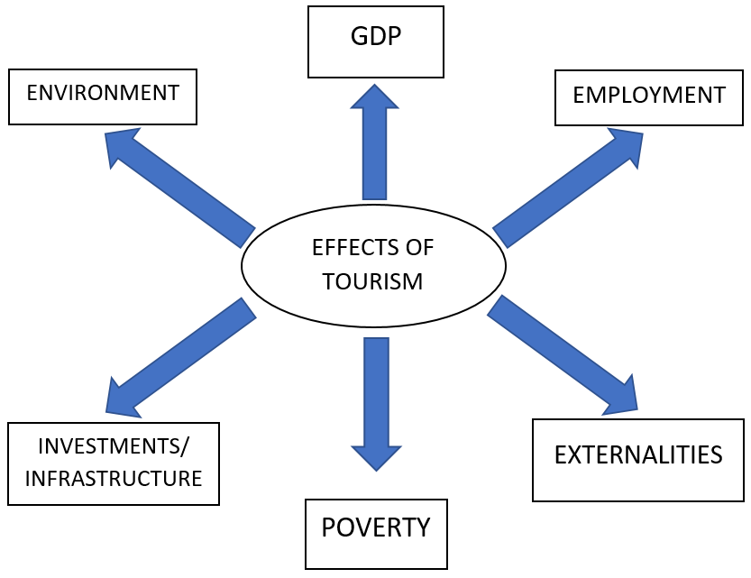
Self-directed learning strategies
- Take ownership of and responsibility for your own learning,
- Try to cover this topic in TWO weeks.
- Use your Core Notes, Mind the Gap or any other prescribed textbook.
- Pace yourself and work consistently.
- Use self-regulatory skills, including how to manage time, handle distractions and control negative emotions.
- Activities are collated into lower, middle and higher order questions. Lower and middle order questions: first tackle these questions using the core notes and/or textbooks provided.
- Make a note of questions /content which you find difficult in order for your teacher to assist at a later stage.
Remember…
Life doesn’t require you to be the best, but to do our best!

ACTIVITIES/ASSESSMENT | Complete the attached activities as provided. Activities cover lower, middle and higher order questions.
CONSOLIDATION | For consolidation purposes, do the following in your notebook:  - Concepts: Write down ALL the concepts that relate to tourism, as well as their definition. Copy them on those mobile notes too and take it with you wherever you go and look at them whenever you can. The more you learn them, the better you will remember them.  - Essays: There are TWO possible essays covered in this topic. Rewrite these TWO essay questions using the appropriate format, i.e. an INTRODUCTION, BODY and CONCLUSION. Make use of Mind Maps and Mnemonics to assist you to memorise the content.  - There are +/- 10 pages that covers the content in your Core Notes or textbook. Read daily at least 1-2 pages.  - Complete the activities as far as possible using the resources provided.
RESOURCES (if necessary) | Paper based resources | Digital resources
 | Mind the Gap: Chapter 13, P180-190  Core Notes: Topic 13, P195-205 | Refer to the relevant digital resources e.g. links on the WCED ePortal  https://www.education.gov.za/Portals/0/Documents/Manuals/2b%20MTG%20Econ%20EN%2018%20Sept%202014.pdf?ver=2014-09-18-121814-000  https://app-eassessment.co.za/

SELF-ASSESSMENT ACTIVITIES  TOURISM  SECTION A QUESTIONS  - Various options are provided as possible answers to the following questions. Choose the answer and write only the letter (A–D) next to the question numbers e.g. 1.1.5 D.  1.1.1 The tourism industry is … intensive.  A capital  B money  C technology  D labour  1.1.2 The main purpose of South African Tourism (SAT) is to  promote South Africa as a tourist destination … tourists.  A to domestic and international  B only to domestic  C only to international  D only to business  1.1.3 Tourism can help to reduce … in South Africa.  A job opportunities  B savings  C poverty  D inflation  1.1.4 Which of the following is an example of an  environmental World Heritage Site?  A Sterkfontein Caves  B Robben Island  C Cape Fynbos Region  D Vredefort Dome  1.2 Choose a description from COLUMN B that matches the item in COLUMN A. Write only the letter (A–I) next to the question number  COLUMN A COLUMN B  1. Community tourism A: labour intensive and employs many skills  2. National Department of Tourism/ B: people travelling from their own countries to visit other countries  3. A uni-visa C: It is a combination of tourism and the environment.  4. Tourism multiplier D: The macroeconomic strategy of the government that is closely linked to tourism is.  5. Destination country E: Drive and direct the tourism policy at national level.  6. Tourism industry F: When tourists are given the opportunity to experience the life in South African townships.  7. Tourism in Transit G: : It is the organisation which promotes tourism.  8. Tourism generating country H: Foreigners visiting South Africa./ When tourists / foreigners are given the opportunity to experience the life in of South African.  9. Internatioal tourist/ Inbound tourist I: It is a visa that is acceptable in all SADC-countries. It is a common visa.  10. World Travel and Tourism Council J: It is a public enterprise with private stakeholder representation on its council.  11. Ecotourism K: It implies that the benefit from a tourist is greater than the money spent.  12. SA Tourism L: The country that tourists visit.  13. Asgi SA/ GEAR M: It is tourists who travel through South Africa for example from Africa to the East, they experience something of the country.  14. Outbound tourist N: Country where tourists come from.  - Give ONE term for each of the following descriptions. Write only the term next to the question number.  1.3.1 Tourism by residents of a country to a foreign country  1.3.2 This type of tourism involves foreigners visiting South Africa  1.3.3 When South Africans travel within the borders of the country  1.3.4 South Africans travelling within the borders of their country  1.3.5 Tourists travelling within their own countries  1.3.6 The culture, history and environment that is unique to the local  people.  1.3.7 South Africans travelling to other countries  1.3.8 The type of tourism where tourists come to South Africa to visit  museums and art galleries  1.3.9 Tourists visiting museums, art galleries and areas that depict a  certain lifestyle, for example the Apartheid museum  1.3.10People travelling to and staying in places outside their usual  environment for no more than one consecutive year  SECTION B QUESTIONS  _.1.1 LOWER ORDER (NAME/GIVE/LIST)  (1 X 2) (2)  3.1.1 Give any TWO examples of transport infrastructure needed for  tourism. (2 x 1) (2)  4.1.1 State any TWO ways in which households can benefit from  tourism. (2 x 1) (2)  4.1.1 Name any TWO types of tourism. (2 x 1) (2)  3.1.1 Give TWO reasons for growth in the tourism industry in South  Africa. (2 x 1) (2)  _.1.2 MIDDLE ORDER (HOW, WHY AND WHAT)  (1 X 2) (2)  3.1.2 How will a sound political climate lead to an increase in  tourist figures? (1 x 2) (2)  4.1.2 How can tourism contribute to government revenue? (1 x 2) (2)  3.1.2 How can tourism influence the lives of poor people near tourist  destinations? (1 x 2) (2)  DATA RESPONSE QUESTION (Items in the data response  questions must be 'scaffolded' from easy to difficult: (2 marks  easy, 4 marks moderate and 4 marks difficult)  4.3 Study the table below and answer the questions that follow:  NUMBER OF TOURISTS FROM EIGHT LEADING OVERSEAS COUNTRIES BETWEEN 2011 AND 2012  COUNTRIES 2011 2012  United Kingdom 420 483 438 023  USA 287 614 326 644  Germany 235 774 266 333  China 84 862 132 327  France 105 420 122 244  Australia 103 506 120 315  The Netherlands 113 846 117 936  India 90 367 106 774  [Adapted from Stats SA, August 2013]  4.3.1 Identify TWO countries that are members of BRICS. (2 x 1) (2)  4.3.2 Define the term tourism. (2)  4.3.3 Determine the percentage change of Chinese tourists to South  Africa between 2011 and 2012. (2)  4.3.4 In your opinion, why is South Africa a preferred tourist destination? (2 x 2) (4)  4.3 Study the cartoon below and answer the questions that follow.  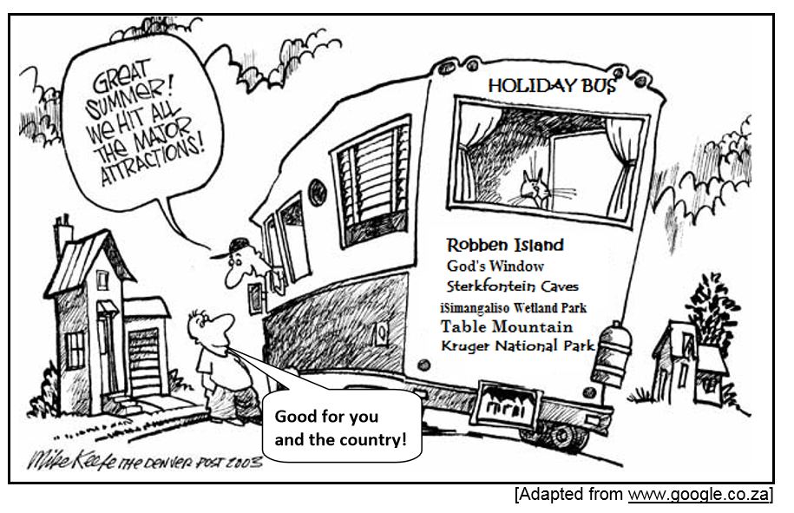  [Adapted from www.google.co.za]  4.3.1 Identify any TWO holiday attractions that people on this bus  are going to visit. (2 x 1) (2)  4.3.2 Briefly describe the term tourism. (2)  4.3.3 How can local communities benefit from nearby tourist  attractions? (2)  4.3.4 Which strategies can be used to promote tourism in South  Africa? (2 x 2) (4) | 4.3 Study the extract below and answer the questions that follow.  TOURISM: A KEY GROWTH SECTOR  Tourism is regarded as a modern-day engine of growth and is one of the largest industries globally. In 2014, G20 heads of state recognised tourism as a driver of growth and development, as well as a sector with the potential to spur global economic recovery.  South Africa has earmarked tourism as a key sector with excellent potential for growth: the government aims to increase the contribution of tourism, both direct and indirect, to the economy.  South Africa's spectacular scenery, friendly people and world-class infrastructure make it one of the most desired destinations in the world.  The regional African tourist market is South Africa's most important tourist market, contributing more than 73% of total tourist arrivals and more than R50 billion in revenue in 2014.  As a labour-intensive sector with a supply chain that links across sectors, tourism is a priority sector in the government's planning and policy frameworks.  [Adapted from South Africa.info, May 2016]  4.3.1Give ONE reason in the extract above why South Africa is  regarded as a very popular tourist destination. (1)  4.3.2 Identify in the extract above why the tourism industry has been  earmarked as a key sector. (1)  4.3.3 Briefly describe the term tourism. (2)  4.3.4 Give ONE reason why the tourism industry is growing at such a  high rate. (2)  4.3.5 In your opinion, how can the tourism industry benefit the poor,  rural communities of South Africa? (2 x 2) (4)  4.2 Study the picture and answer the questions that follow.  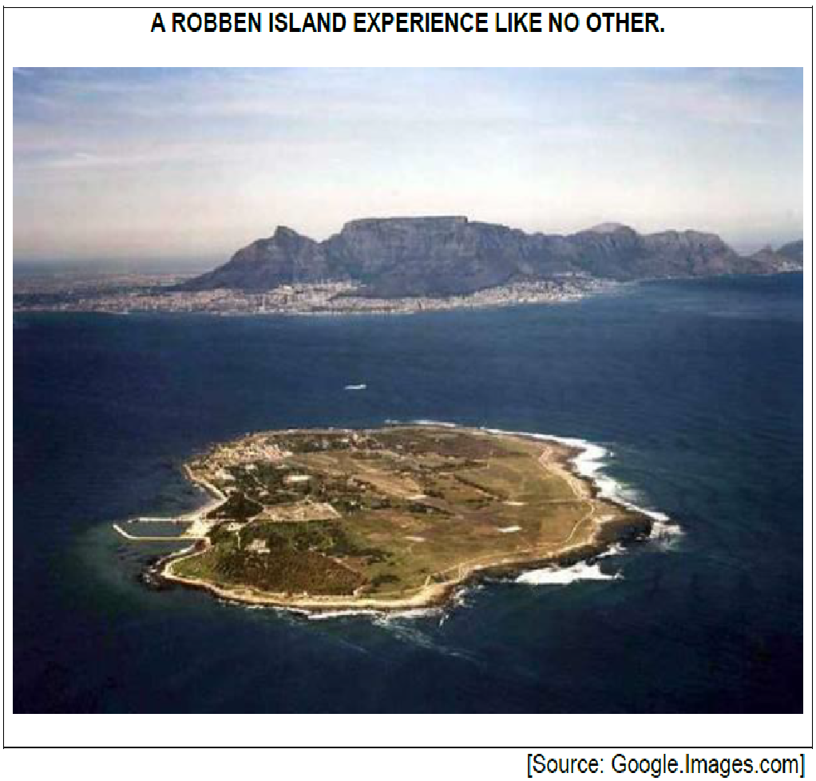  4.2.1 Close to which city is Robben Island situated? (1)  4.2.2 Robben Island can be categorised as a … site. (1)  4.2.3 Why is Robben Island labelled as ‘an experience like no other’? (4)  4.2.4 Explain any TWO ways in which tourism can be promoted.  (4)  3.2 Study the table below and answer the questions that follow.  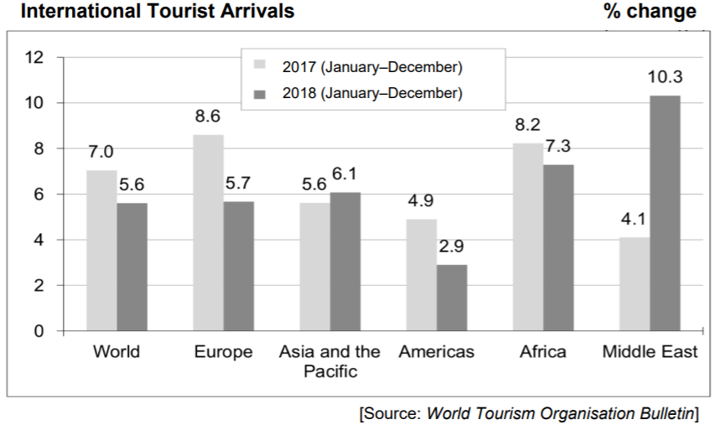  3.2.1 Where did most inbound tourists come from during 2017?  (1)  3.2.2 What was the percentage increase of tourists from the  Middle East? (1)  3.2.3 Briefly describe the term business tourism. (2)  3.2.4 Why is job creation easy in the tourism industry? (2)  3.2.5 What should the government do to promote tourism?  (2 x 2) (4)  4.3 Study the advertisement below and answer the questions that follow.  4.3.1 What type of tourism is depicted in the picture above? (1)  4.3.2 Which organisation is responsible for marketing tourism in  South Africa? (1)  4.3.3 Briefly describe the term indigenous knowledge systems.  (2)  4.3.4 Why is it necessary to have controlled visits to the various  SANParks in South Africa? (2)  4.3.5 How can the marketing of World Heritage Sites benefit local  communities? (2 x 2) (4)  4.3 Study the extract below and answer the questions that follow.  SA tourism growth beats world average South Africa stands out as a tourist destination in the world. Last year we grew at more than double the world average, 10.5% for January to November 2012, compared to a global average growth of four percent. With growth rates of more than double the world average and quadruple the world average if one takes overseas visitors into account, we can look back very favourably on 2012. Tourism remained stable in South Africa in the midst of the 2008/2009 global financial crisis. South Africa is indeed a unique and varied destination which offers tourist experiences that suit every taste and budget.  Source: South Africa.info (Brand South Africa country portal), 18 April 2013  4.3.1 How does SA’s annual growth rate in tourism compare to  the rest of the world?  Supply figures to substantiate your answer. (2)  4.3.2 Define negative externalities. (2)  4.3.3 What is the significance of indigenous knowledge to modern  tourism? (2)  4.3.4 In your opinion, what are the reasons for the rapid growth of  tourism in South Africa? (2x2) (4)  3.3 Study the extract below and answer questions that follow.  WEAK RAND CAN BENEFIT SOUTH AFRICA'S TOURISM  South Africa's currency has reached its lowest level since 2001. This is great news for international tourists who can take advantage of a very favourable exchange rate to visit South Africa. Now, more than ever, South Africa offers great value for money and has become one of the greatest holiday destinations for international travellers.  South Africa offers vacation options to suit every pocket and taste. Travellers are truly spoilt for choice from hotel and safari lodge accommodation, restaurants offering local and international cuisine, access to the Big Five wildlife and spectacular, breath-taking scenery.  [Source: www.eturbonews.com]  3.3.1 Identify TWO goods or services on which tourists can spend  money in South Africa in the extract above. (2 x 1) (2)  3.3.2 Explain the term tourism. (2)  3.3.3 How does a weaker rand affect the South African tourist? (2)  3.3.4 How can an increase in tourism benefit South African  households? (2 x 2) (4) | 3.3 Read the extract below and answer the questions that follow.  BETTER MEDICAL FACILITIES IN SOUTH AFRICA CONTINUE  TO INFLUENCE MEDICAL TOURISM GROWTH  There is a general increase being recorded in the number of people visiting South Africa in search of medical treatment from the country's many healthcare institutions, which are considered to have superior facilities and high levels of medical expertise.  Medical tourists are received mostly from other African countries which may lack the appropriate medical facilities with proper equipment to perform challenging surgical procedures. Inbound medical tourists from overseas often travel to South Africa for surgical procedures which are considered relatively expensive in other countries such as the USA and the UK.  [Source: www.euromonitor.com]  3.3.1 What, according to the extract, is the reason for the growth in  the tourism industry? (2)  3.3.2 Explain the term tourism. (2)  3.3.3 Why is South Africa such a popular holiday destination? (2 x 1) (2)  3.3.4 How will the economy benefit from an increase in the number of  medical tourists coming to South Africa? (2 x 2) (4)  3.2 Study the table below and answer the questions that follow.  INTERNATIONAL TOURIST ARRIVALS IN SOUTH AFRICA  MARKETS 2014 2015  Africa (land) 1 713 543 1 617 570  Africa (air) 102 006 95 332  Americas 107 859 92 710  Asia and Australasia 103 903 81 498  Europe 405 894 402 223  Total tourist arrivals 2 435 341 2 292 169  [Source: www.southafrica.net]  3.2.1 Identify TWO markets in the table that contributed the most to  Tourism in South Africa during 2015. (2 x 1) (2)  3.2.2 Suggest possible reasons that have led to a general decline in  international tourism in 2015. (2 x 2) (4)  3.2.3 Calculate the percentage decline in total tourist arrivals in  South Africa between 2014 and 2015. Show ALL calculations  (4)  3.2 Study the table below and answer the questions that follow.  SELECTED PLACES OF ORIGIN OF SOUTH AFRICA'S  INTERNATIONAL TOURISTS FOR 2012–2013  PLACE OF ORIGIN NUMBER OF TOURISTS MAY 2012 NUMBER OF TOURISTS MAY 2013  Europe 75 039 75 946  North America 35 151 35 114  Central and South America 86 008 85 591  Africa 519 432 527 185  Total 723 672 733 507  [Source: South African Tourism Report]  3.2.1 Identify the continent contributing most to an increased number  of people visiting South Africa in 2013. (1)  3.2.2 How can you contribute to an increase in the number of  international tourists visiting your community? (1 x 2) (2)  3.2.3 Determine the trend of tourists visiting South Africa from  Central and South America. Quote figures from the table to  support your answer. (2)  3.2.4 Calculate the percentage increase in the total number of  tourists visiting South Africa. Show ALL calculations. (4)  3.3 Study the information below and answer the questions that follow.  INDIGENOUS KNOWLEDGE SYSTEM HAS THE POTENTIAL TO STIMULATE THE ECONOMY  Researchers and traditionalists believe that Aloe Ferox, an indigenous plant, has the potential to benefit people in the rural and urban areas in South Africa. The plant, popularly known as Ikhala, can be found on rocky hills, grassy and dry lands. It is used for medicinal purposes for both humans and animals. The idea is to exploit the huge international demand for Aloe Ferox products.  [Adapted from www.google.co.za]  3.3.1 Identify the African name for the plant, Aloe Ferox, in the  extract above. (1)  3.3.2 According to the information above, what is the reason for the  high international demand for Aloe Ferox products? (1)  3.3.3 Briefly describe the term indigenous knowledge system. (2)  3.3.4 How can commercial use of Aloe Ferox contribute to  government revenue? (2)  3.3.5 How can Aloe Ferox plants be used to reduce unemployment  in rural and urban areas? (2 x 2) (4)  MIDDLE ORDER QUESTION  (EG EXPLAIN, DISCUSS, DISTINGUISH OR  DIFFERENTIATE BETWEEN) – (8 MARKS)  4.4 Explain any TWO ways in which households benefit from tourism. (2 x 4) (8)  3.4 Explain the benefits of tourism for businesses and government.  (2 x 4) (8)  3.4 What are the benefits of tourism to households? (4 x 2) (8)  3.4 Briefly discuss the benefits of tourism for the government and  infrastructure. (2 x 4) (8)  3.4 Explain the effects of increased tourism on poverty. (4 x 2) (8)  4.4 Explain the effects of tourism on the environment and poverty (2 x 4) (8)  3.4 Discuss the economic benefits of tourism for the government and  infrastructure development. (2 x 4) (8)  HIGHER ORDER QUESTIONS  (E.G. HOW, WHY, DRAW A FULLY LABELLED  GRAPH AND EXPLAIN, CALCULATE. EXPRESS AN  OPINION) (8 MARKS)  4.5 What has contributed to an increase in tourism worldwide? (4 x 2) (8)  3.5 In your opinion, why has South Africa experience a growth in  tourism? (4 x 2) (8)  3.5 What is the impact of indigenous knowledge within the South  African context on tourism? (4 x 2) (8)  3.5 How will you advise the Minister of Tourism to overcome the  impact of negative externalities generated by tourism? (4 x 2) (8)  4.5 What has contributed to an increase in tourism?  (4 x 2) (8)  3.5 Discuss why the loss of indigenous knowledge requires  international measures. (4 x 2) (8)  SECTION C  ESSAYS QUESTIONS: (26 MARKS)  1. Discuss the effects of tourism. (26 marks)  2. Examine the effects of tourism on the following: o Poverty  o Employment  o Externalities (26 marks)  3.Discuss the benefits of tourism for:  − Business (10 marks)  − Infrastructure (8 marks)  − Households (8 marks) (26 marks)  ADDITIONAL PART :10 MARKS QUESTIONS  Evaluate the success of indigenous knowledge systems  (IKS) in promoting tourism in South Africa. (10 marks)  How can South Africa promote domestic tourism? (10 marks)  How can tourist attractions in less popular destinations be marketed  successfully? (10 marks)  What is the impact of the current Covid-19 pandemic on the tourism  industry of South Africa? (10 marks)

